Tableau Exercise 3 Answers

Mathew Doty

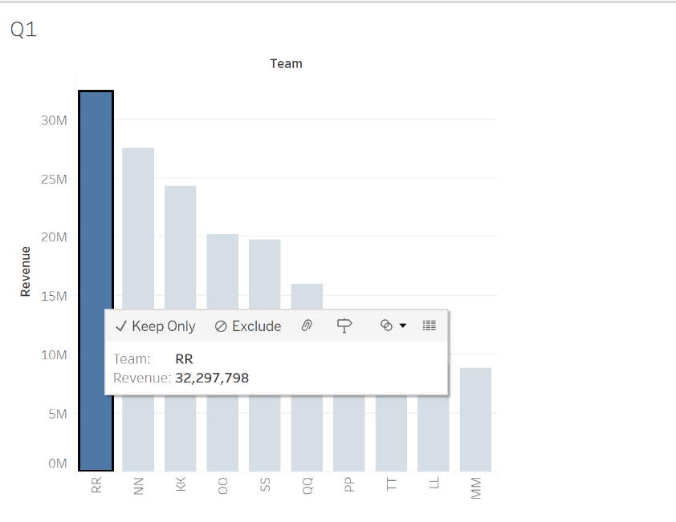

1. RR with $32,297,798

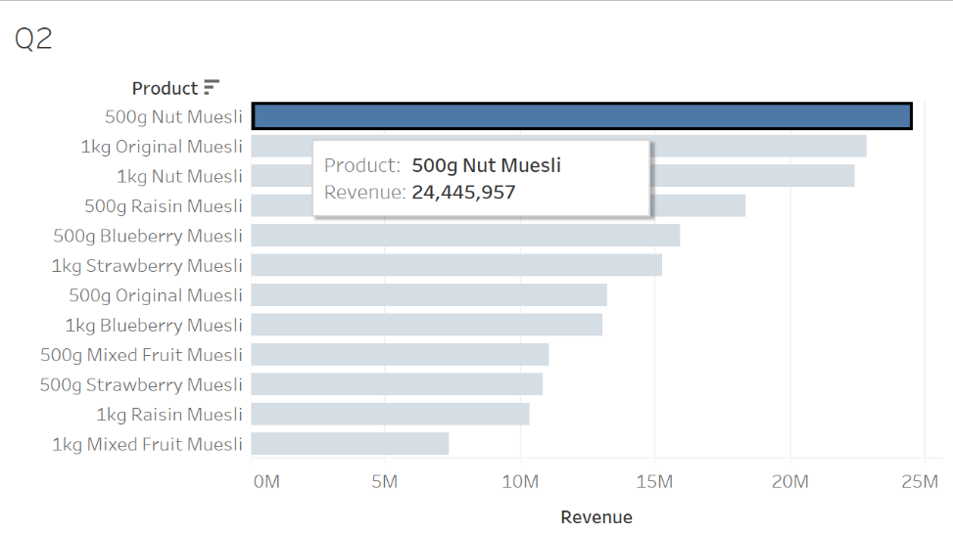

1. 500g Nut Muesli with $24,445,957

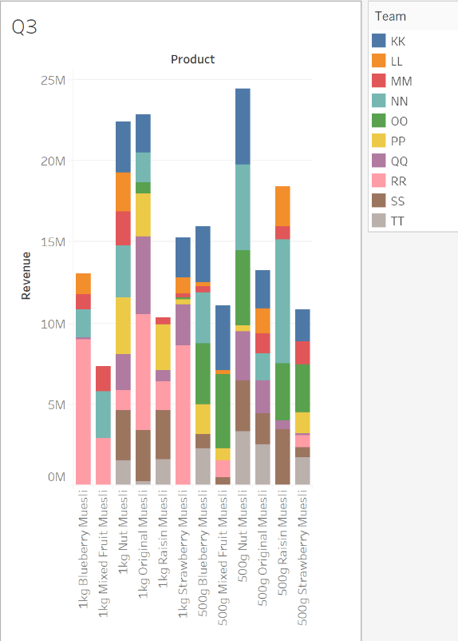

1. It seems that every team sells at over 4 different products.
2. 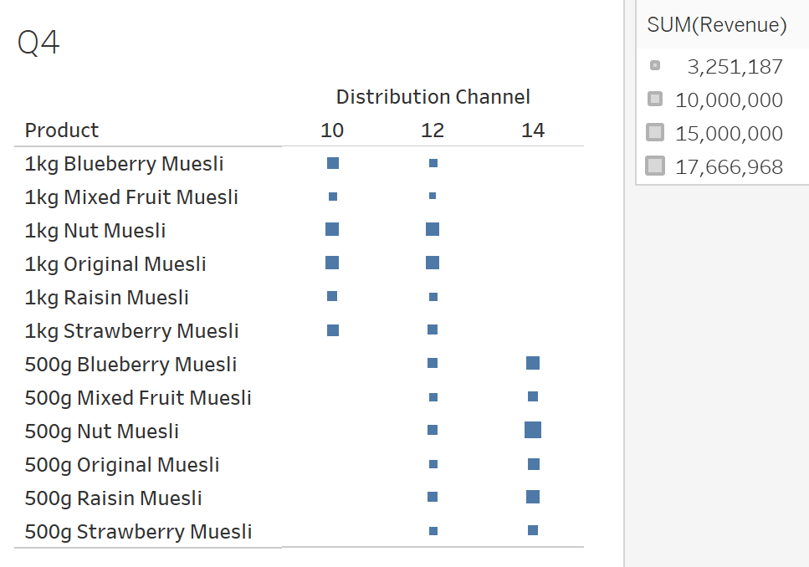The distribution channels on 14 for all 1kg products and the distribution channels on 10 for all 500g products do not show any activity.

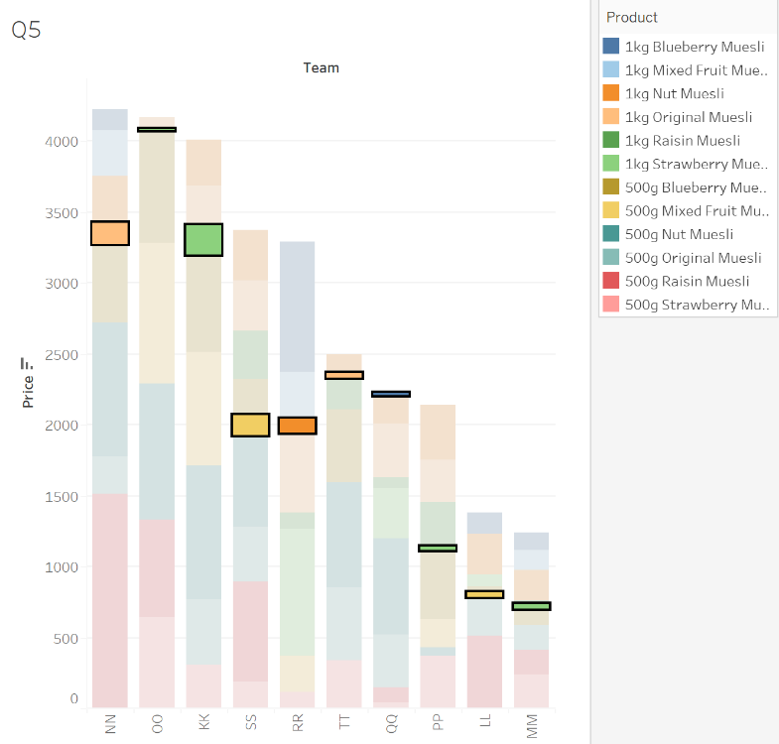

1. NN: 1kg Original Muesli - $149; OO: 1kg Strawberry Muesli - $9; KK: 1kg Strawberry Muesli - $213; SS: 500g Mixed Fruit - $137; RR: 1kg Nut Muesli - $93; TT: 1kg Original Muesli - $27; QQ: 1kg Blueberry Muesli - $10; PP: 1kg Strawberry Muesli - $23; LL: 500g Mixed Fruit Muesli - $36; MM: 1kg Strawberry Muesli - $30

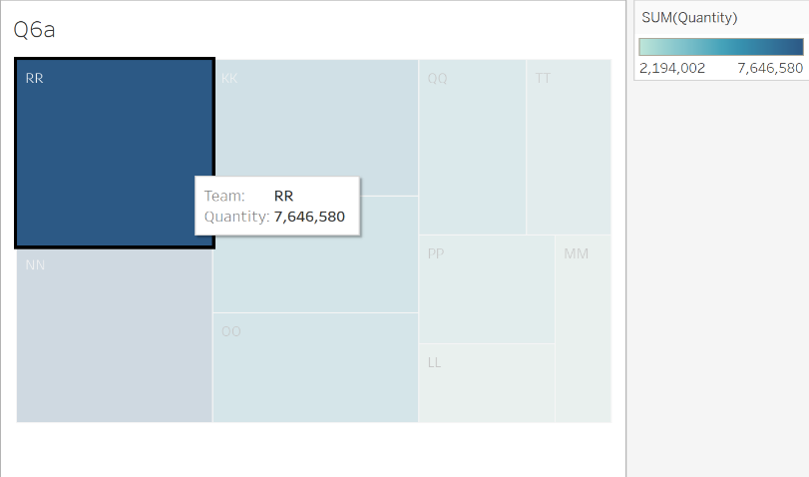

* 1. For this one, I instead put Quantity in Color and Size and Team in Label. RR sold the most with 7,646,580.
  2. 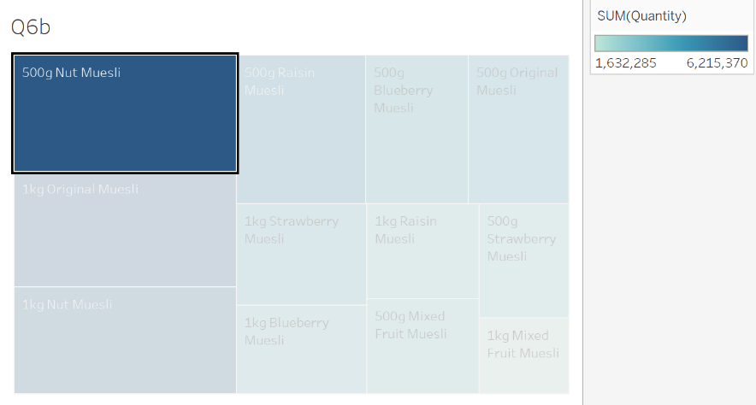500g Nut Muesli had the most with 6,215,370.

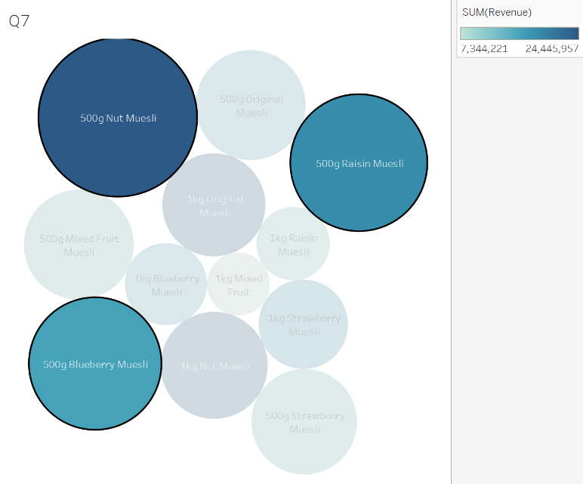

1. 500g Nut Muesli: Price-$4,979, Revenue-$24,445,957; 500g Raisin Muesli: Price-$3,701, Revenue-$18,383,968; 500g Blueberry Muesli: Price-$3,460, Revenue-$15,936,378
2. 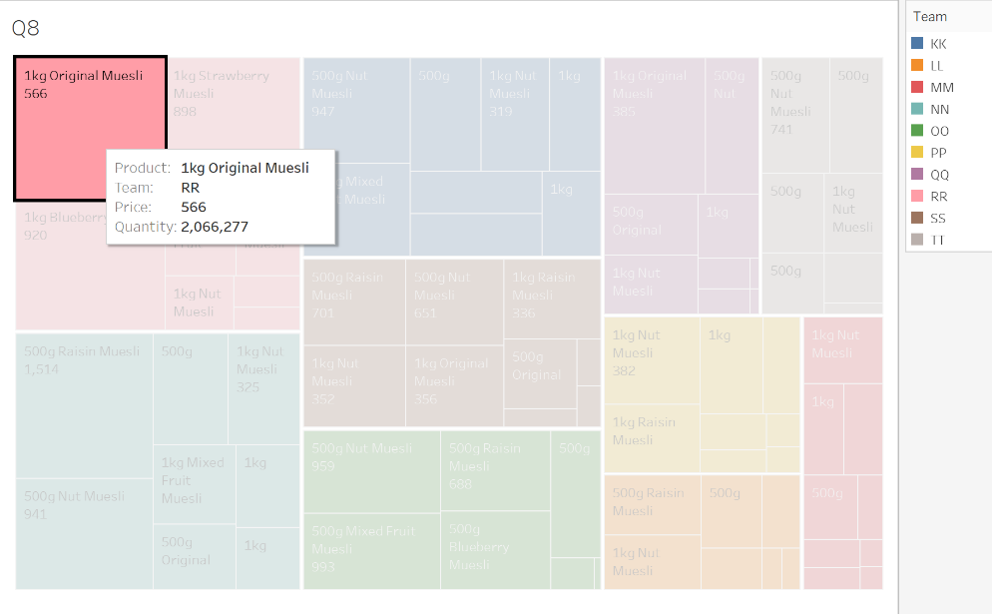As found in 6a, RR sold the most with 7,646,580. Of those, the 1kg Original Muesli was the most often sold with 2,066,277 sold at $566.